Cathie Harrop with Dave Khan and Jennie Khan
Kumeu Arts Centre, 300 Main Rd, Kumeu, Auckland
Saturday 31 August 2019 8:00pm – 10:00pm
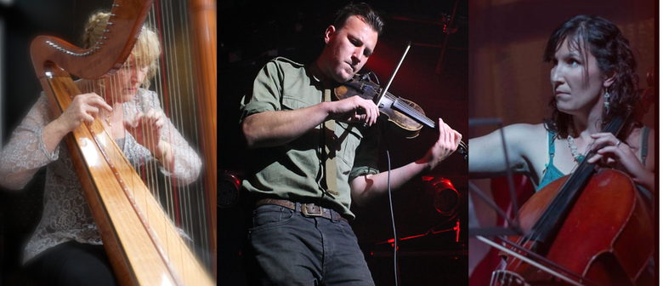

CATHIE HARROP

AT KUMEU LIVE

-ANOTHER SIDE-
Come and see another side of Cathie at this intimate venue as she performs some of the great songs she has recorded over the years since she first arrested audiences with her voice and harp.
She will be a supported by Jennie and Dave Khan as she explores her many musical facets.
Kumeu Live held at the Kumeu Arts Centre Main Highway Kumeu, is a not for profit organization that provides a relaxed atmosphere where an audience can listen to live music. With subtle lighting, very good sound and high quality artists, Kumeu Live is gaining a reputation with audiences and performers alike.
The venue is BYO – so bring your favourite tipple and glasses will be provided.

For more information and tickets ($20) on line go to Under The Radar

Or - Phone 09 479 2361 to talk to someone.

Or - Go the www.cathieharrop.com and fill in the booking form.

